UNIVERSITY OF CENTRAL PUNJAB



Name: Hafiz Abdul Hannan

Reg No: L1F22BSCS0322

Section: G-10

Submitted To: Ms. Aneela Mehmood

Github-link: https://github.com/HafizAbdulHannan/Siraiki-Lexical-Analyzer

Compiler Construction: Project Phase 1
Project - Introduction:

This project involves the design and implementation of a Lexical Analyzer (Scanner) using Flex, developed as part of the Compiler Construction (Phase 1) coursework.
The primary objective of this scanner is to read source code written in a Mini C++-like language and decompose it into meaningful tokens. A distinguishing feature of this project is its unique customization: it utilizes a set of over 15 keywords derived from the Siraiki language (such as adad, jay, natan, and wila), giving the language a distinct regional identity.
Key functionalities of this Lexical Analyzer include:
- Token Recognition: Efficiently classifying input into Keywords, Identifiers, Numbers (Integers, Floats, and Exponents), Operators, and Punctuations.
- Line Tracking: Reporting the specific line number for every token to facilitate easier debugging.
- Error Handling: Robust detection of lexical errors—such as invalid identifiers (e.g., 1value) or unrecognized characters—reported with precise line numbers.
Overall, this project demonstrates the practical application of Lexical Analysis, providing a deep understanding of how compilers recognize and process the fundamental building blocks of a programming language.

1. Language Overview
Language Name: S++ (Siraiki++)
Theme:
S++ is a Siraiki-inspired programming language designed to bridge the gap between the structured logic of C++ and the linguistic familiarity of the Siraiki culture.
It utilizes Siraiki keywords (such as adad, jay, natan, valval) and a simplified syntax to make the coding experience feel natural, expressive, and culturally inclusive. Just as C++ extended the capabilities of C, S++ extends logic with culture, making programming concepts far easier to grasp for beginners who think and communicate in Siraiki.

Purpose:
The primary purpose of S++ is to eliminate the language barrier in computer science education.
By replacing complex English terminology with familiar Siraiki words, the language empowers students to:
- Understand programming logic faster by removing linguistic obstacles.
- Focus on reasoning and problem-solving, rather than rote memorization of English syntax.
- Feel comfortable and confident learning complex technical concepts in their mother tongue.

Goals:
The core objectives of S++ are to:
- Simplify programming logic through the use of intuitive Siraiki syntax.
- Promote linguistic inclusion within the field of computing and technology.
- Support regional education by introducing indigenous coding tools tailored for local students.
- Facilitate a smooth transition for learners moving from native-language logic to standard languages like C++ or Java.
- Encourage creativity and build confidence among non-English-speaking students in Pakistan.

Regex Table

Token Type | Regular Expression (Regex) | Example Tokens
Keywords | adad | isharia | akhar | wila | jay | natan | valval | jitna | wapas | ghin | likh | khal | agoo | wadda | sahi | ghalat | jay, valval, likh
Identifier | [a-zA-Z_][a-zA-Z0-9_]* | myVar, total_sum, _count
Integer | [0-9]+ | 123, 0, 95
Float | [0-9]+"."[0-9]+ | 3.14, 0.5
Exponential | [0-9]+"."[0-9]+([eE][-+]?[0-9]+)? | 1.2E+05, 5.5e-10
String | `"([^"\] | \[\"tn])*"`
Character | '[^']' | 'A', 'x', '9'
Operators | + | - | * | / | = | == | > | < | >> | << | +, ==, <<
Punctuation | { | } | ( | ) | ; | , | {, }, ;

Finite Automata

Keywords

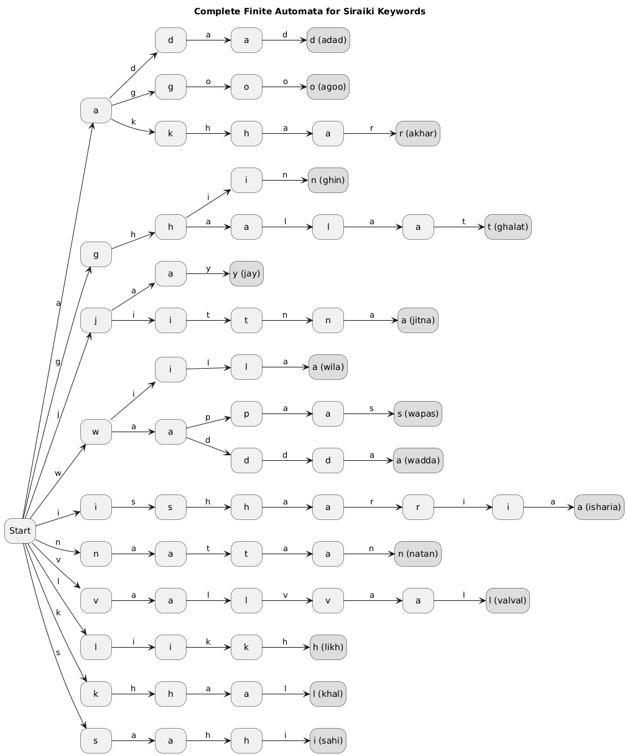

Numbers:

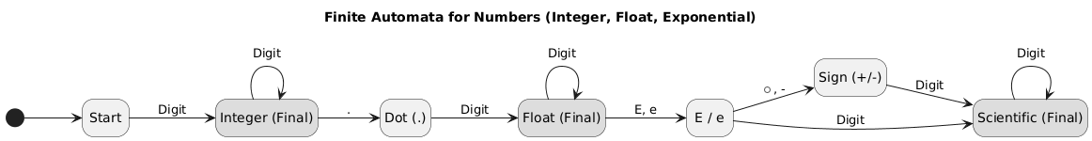

Identifiers:

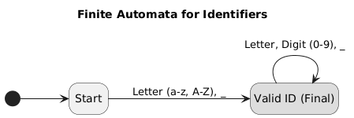

Code:
wila wadda() {

adad x = 10;
adad y = 20;
isharia z = 5.5;
isharia exp = 1.2E+05;

akhar grade = 'A';

likh << "Program shuru thee wanjho";

jay (x < y) {
likh << "X chhoto aa";
x = x + 1;
}
natan {
likh << "Y chhoto aa";
}

valval (adad i = 0; i < 5; i = i + 1) {
likh << i;
jay (i == 3) {
khal;
}
}

adad count = 0;
jitna (count < 10) {
count = count + 1;
}

wapas 0;
}
Tokens:
